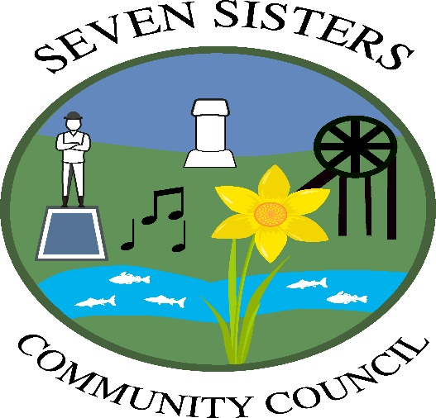
Linda Oliver
Clerk to the Council
Brodawel, Onllwyn Road
Neath SA10 9NS
Tel: 01639 700525/07774 718663
linoliver@btinternet.com
www.sevensisterscommunitycouncil.org

SEXTON FOR BRYNBEDD CEMETERY

The Community Council is looking for someone to act as Sexton for Brynbedd cemetery in Seven Sisters.

This is a voluntary post, but a small remuneration would be paid for each burial/internment

The post involves the following:

Liaising with Funeral Directors when a burial/internment takes place

Liaising with the grave digger

Recording burials/internments in register

Filing burial/cremation certificates

Regularly inspecting the cemetery and reporting any problems to the Community Council

Please apply to Linda Oliver, Clerk to Council by email or in writing. Details as above.

Closing date for applications: 23rd December 2024

9th December 2024

